Interfacing LEDs to 8051 and displaying Binary Patterns


LAB # 02

Spring 2024
CSE-307L Microprocessor Based System Design Lab

Submitted by: Ali Asghar
Registration No.: 21PWCSE2059
Class Section: C

“On my honor, as student of University of Engineering and Technology, I have neither given nor received unauthorized assistance on this academic work.”

Submitted to:
Dr. Asif Ali Khan

Date:
25th February 2024

Department of Computer Systems Engineering
University of Engineering and Technology, Peshawar

Task 1:
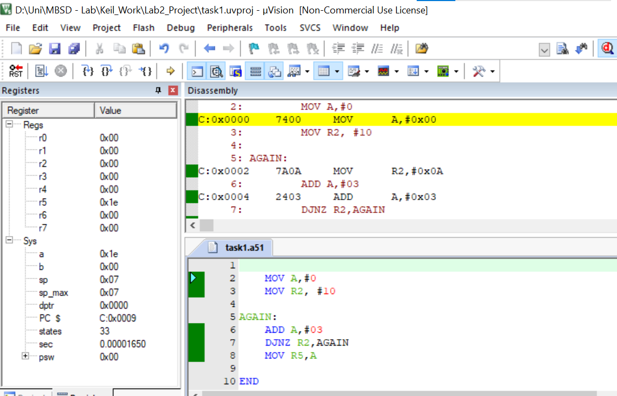

Task 2:
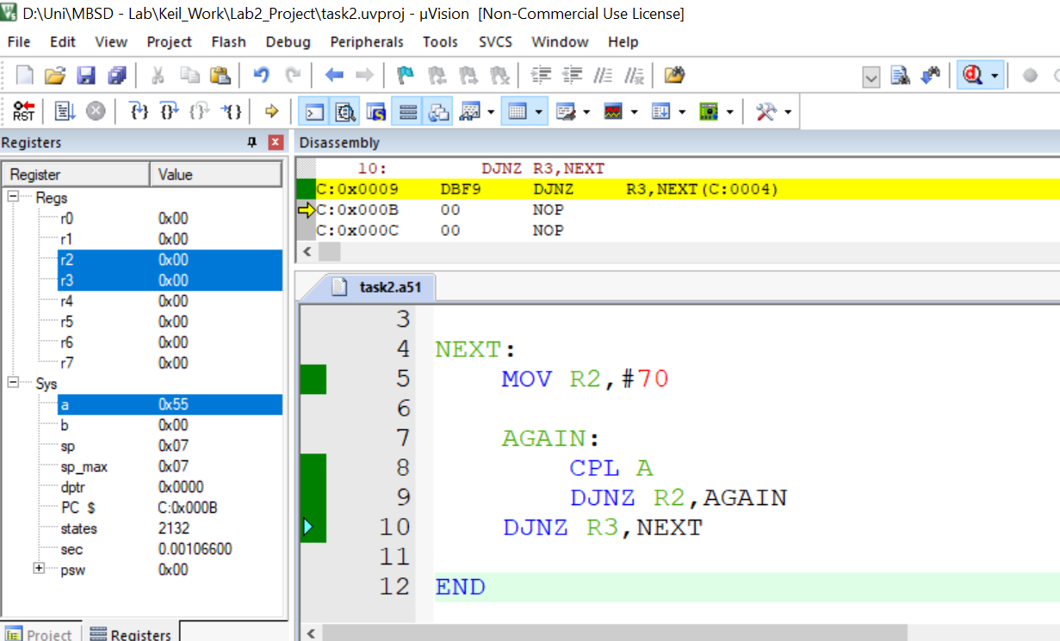

Task 3:
Code:
Using Assembly
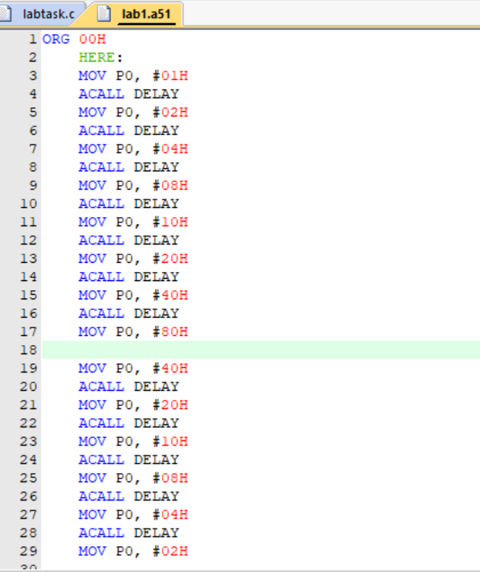
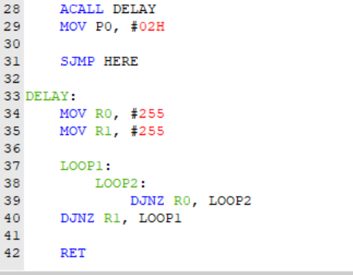

Using C
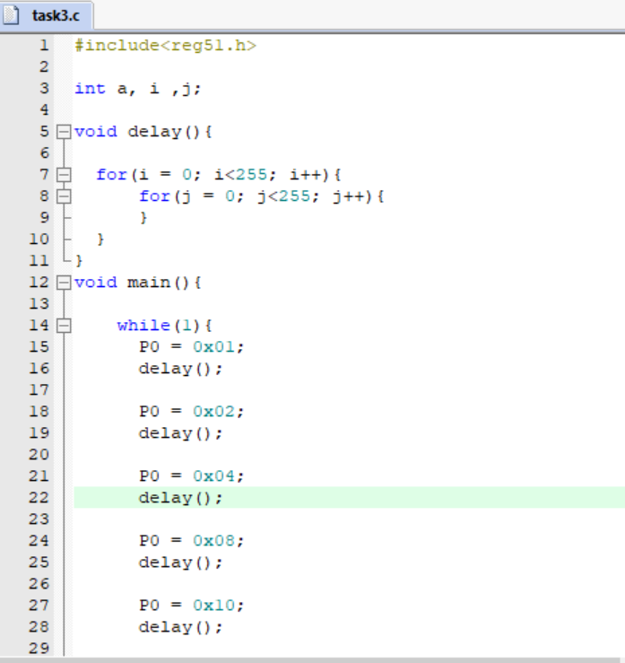
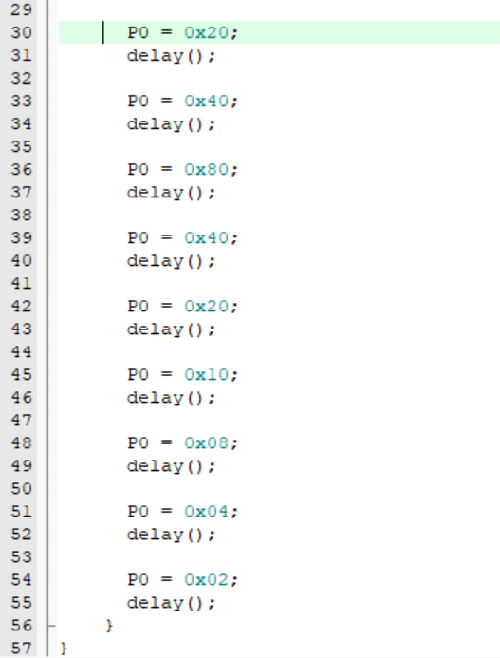

Output:
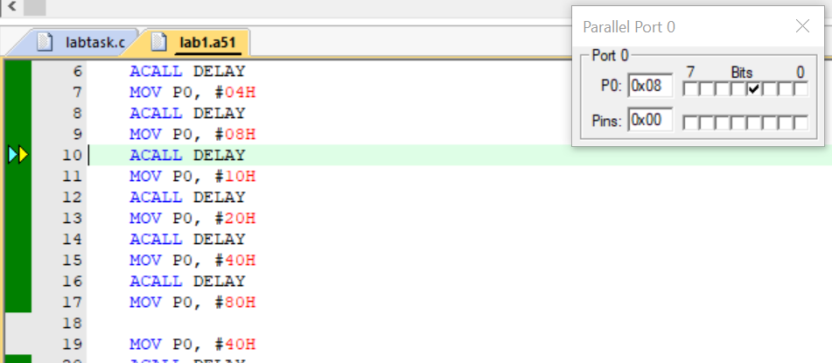

Proteus Simulation:
